

Name : Adil Khan
Roll No : 2330-0030
Dept: BS AI
Subject: Data Base system

Lab no 7:

CREATE DATABASE Megamart;
USE Megamart;
CREATE TABLE sales_data (
sale_id INT AUTO_INCREMENT PRIMARY KEY,
salesman_name VARCHAR(50),
region VARCHAR(30),
product_category VARCHAR(50),
quantity INT,
total_amount DECIMAL(10,2),
sale_date DATE
);
INSERT INTO sales_data (salesman_name, region, product_category, quantity, total_amount, sale_date)
VALUES
('Ali', 'North', 'Mobile', 10, 120000.00, '2025-01-15'),
('Sara', 'South', 'Laptop', 5, 350000.00, '2025-02-10'),
('Ahmed', 'East', 'TV', 3, 180000.00, '2025-03-18'),
('Raza', 'West', 'Tablet', 8, 96000.00, '2025-03-20'),
('Ali', 'North', 'Laptop', 4, 280000.00, '2025-04-05'),
('Sara', 'South', 'Mobile', 12, 144000.00, '2025-04-12'),
('Ahmed', 'East', 'Laptop', 6, 420000.00, '2025-04-25'),
('Raza', 'West', 'TV', 5, 300000.00, '2025-05-03'),
('Ali', 'North', 'TV', 2, 120000.00, '2025-05-18'),
('Sara', 'South', 'Tablet', 9, 117000.00, '2025-06-08'),
('Ahmed', 'East', 'Mobile', 7, 84000.00, '2025-06-20'),
('Raza', 'West', 'Laptop', 3, 210000.00, '2025-07-02');
Task no 1:
SELECT region AS Region,
COUNT(*) AS Total_Sales_Records,
SUM(quantity) AS Total_Quantity_Sold,
SUM(total_amount) AS Total_Sales_Amount,
AVG(total_amount) AS Average_Sale_Amount_Per_Record
FROM sales_data
GROUP BY region;
Output:
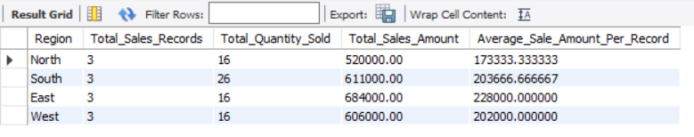
Task no 2:
SELECT product_category AS Product_Category,
SUM(quantity) AS Total_Quantity_Sold,
MAX(total_amount) AS Highest_Sale_Amount,
MIN(total_amount) AS Lowest_Sale_Amount
FROM sales_data
GROUP BY product_category;
Output:
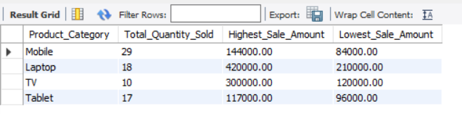
Task no 3:
SELECT region AS Region, product_category AS Product_Category,
SUM(quantity) AS Total_Quantity_Sold,
SUM(total_amount) AS Total_Amount_Earned
FROM sales_data
GROUP BY region, product_category
ORDER BY region, product_category;
Output:
